Day: 19 (06-11-2026) | DAX Functions, New Measures & Hide columns in Power BI | Documented By:
Task – 2 | DAX Functions, New Measures & Hide columns in Power BI | Sujit T K

- SUM()
Use DAX Function SUM() on revenue field to calculate ‘Total Revenue’ measure
Total Revenue = SUM(ORDERS[REVENUE])

- AVERAGE()
The DAX function AVERAGE() on revenue helps to derive ‘Average Revenue’ measure
Average Revenue = AVERAGE(ORDERS[REVENUE])

- COUNTROWS()
DAX Function COUNTROWS() can be used to deduce measure ‘total number of orders’
Total Orders = DISTINCTCOUNT(ORDERS[ORDER_ID])

- DISTINCTCOUNT()
The DAX function DISTINCTCOUNT() helps to calculate measure ‘Total Customers’. It skips the duplicated values.
Total Customers = DISTINCTCOUNT(ORDERS[CUSTOMER_NAME])

- DIVIDE()
A DAX function that takes in two numeric values and performs arithmetic division. If the division results in NaN, then the third value is substituted.
Average Order Value = DIVIDE([Total Revenue] / [Total Orders])

- IF()
A control statement that checks on a boolean condition and substitutes second argument value if true or substitutes third argument value if false otherwise.

- CALCULATE()
Calculates an expression a er applying a specified filter condition.
Fitness item Sales = CALCULATE( ORDERS[Total Revenue], ORDERS [PRODUCT_CATEGORY] = "Fitness" )

- SUMX()
Calculates an expression row by row and adds all the results.
Total Revenue = SUMX( ORDERS, ORDERS[QUANTITY] * ORDERS[UNIT_PRICE] )
This calculates total revenue for each row.

- SWITCH()
Checks multiple conditions and returns the matching result.
Overall Sales = SWITCH( TRUE(), [Total Revenue] >= 100000, "HIGH", [Total Revenue] >= 75000, "NORMAL", "LOW")
This determines the value of overall sales based on total revenue.

- Hide all the unnecessary fields (columns)
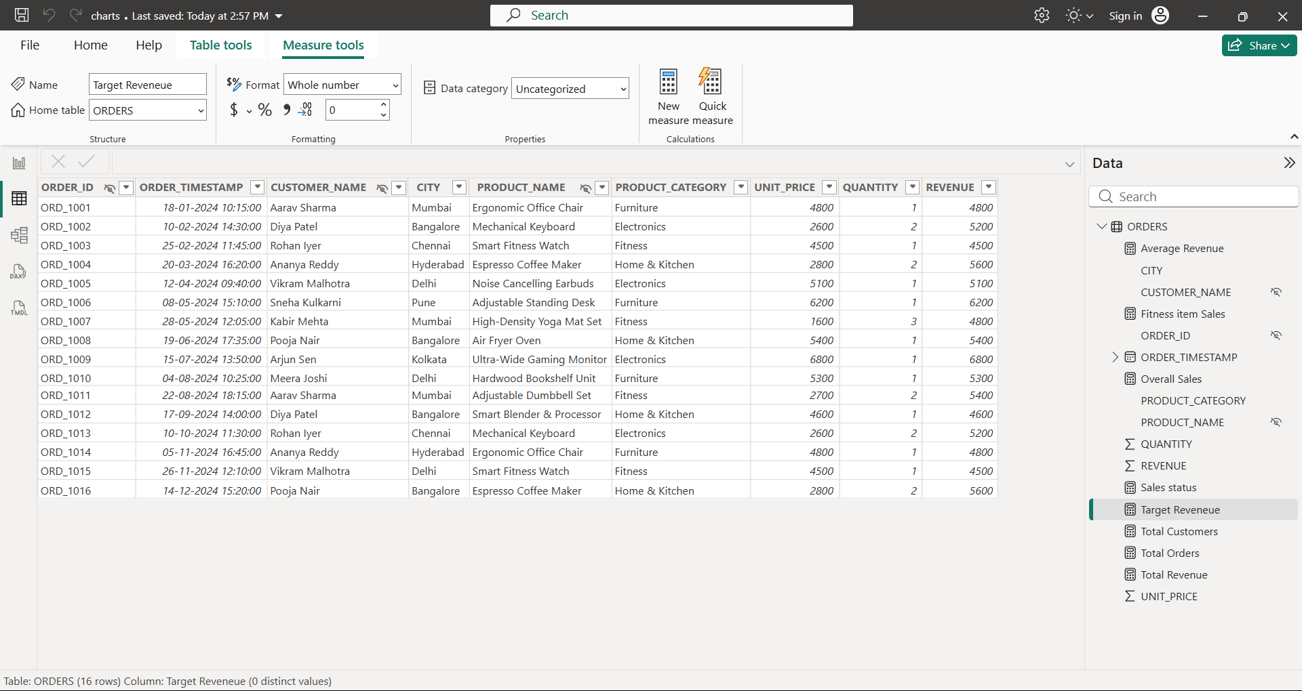
Order ID, Customer Name and Product Name are hidden in reports view.
- With newly created measures, design the dashboard using cards, bar graph, scatter plot, donut chart and other types of charts.


